

Capstone Project Proposal

Semester: Spring 2026

Student Name: ARIF HASAN (Team member 1)
Student ID: 0242220005341044
Student Name: Yeasir Arafat (Team member 2)
Student ID: 242310005341034

Batch: 40
Section: H (1)
Course Code: SE133
Course Name: Software Engineering Design Capstone Project
Course Teacher Name: Md. Rashedul Alam
Submission Date: 24/01/2026

Introduction
In the digital era, online shopping has revolutionized the way consumers purchase goods and services. The increasing demand for convenience, accessibility, and variety has led to the rapid growth of e-commerce platforms. This project aims to develop a comprehensive Online Shopping System that provides a seamless, user-friendly, and secure shopping experience. The system will allow users to browse products, place orders, make secure payments, and track their purchases efficiently. Additionally, it will incorporate an intuitive admin panel for product and order management, ensuring smooth operations for business owners.
This system will be built using modern web technologies, integrating essential features such as product search and filtering, customer reviews, real-time order tracking, and secure payment gateways. With a focus on scalability and security, the Online Shopping System will cater to both small businesses and large enterprises, ensuring a robust and reliable e-commerce solution.

Objective
The primary objective of this project is to design and develop an Online Shopping System that enhances the e-commerce experience for both customers and business owners. The key objectives include:
- User-Friendly Interface – Develop an intuitive and responsive user interface for seamless navigation and shopping.
- Secure Transactions – Implement secure payment gateways and data encryption to protect user information.
- Efficient Order Management – Enable customers to place, track, and manage orders in real time.
- Admin Dashboard – Provide an admin panel for product management, order processing, and sales analytics.
- Scalability & Performance – Ensure the system can handle high traffic and scale as the business grows.
- Customer Engagement – Integrate features like product reviews, recommendations, and personalized offers.
- Multi-Platform Accessibility – Make the system accessible on desktops, tablets, and mobile devices.
By achieving these objectives, the Online Shopping System will serve as a reliable and efficient e-commerce solution, improving user experience and business operations.

Scenario Writing for Stakeholders in the Online Shopping System
The Online Shopping System involves multiple stakeholders, each with different roles, interactions, and expectations from the system. Below are scenario-based descriptions for each stakeholder:

1. Customer
Scenario:
Robi is a frequent online shopper looking for trendy leather accessories. He visits the Online Shopping System, browses through different categories, and finds a leather wallet he likes. He adds it to his cart and proceeds to checkout. After selecting a payment method and entering his shipping details, he confirms the order. He receives an email confirmation and a tracking number to monitor his shipment. A few days later, he receives his order and rates the product with a review.
Expectations:
- Easy product search and filtering
- Secure and smooth checkout process
- Order tracking and status updates
- Customer support for inquiries and complaints

2. Seller/Admin (Business Owner/Store Manager)
Scenario:
Sara owns a fashion accessories store and wants to expand her business online. She logs into the admin panel of the Online Shopping System, where she can add new products, update inventory, and manage orders. She receives a new order notification and processes it for shipment. The system automatically updates the stock levels, and she can monitor sales analytics to track her store's performance.
Expectations:
- Product and inventory management tools
- Order and shipment processing capabilities
- Sales reporting and analytics dashboard
- Ability to manage promotions and discounts

3. Delivery Agent
Scenario:
Rahim is a delivery agent assigned to deliver an order from the Online Shopping System. He logs into the delivery portal, views the pending deliveries, and updates the system when he picks up the package. Using the system’s real-time tracking, he updates the status as "Out for Delivery." Once he delivers the product to the customer, he marks the order as "Delivered," and the customer receives an automated notification.
Expectations:
- Access to assigned deliveries with customer details
- Ability to update real-time order status
- GPS tracking and route optimization for delivery efficiency
- Proof of delivery collection (e.g., signature or OTP verification)

4. System Administrator
Scenario:
The system administrator, John, is responsible for managing the platform’s security, maintenance, and user accounts. One day, he receives a report of an unusual transaction. He logs into the admin control panel, checks the activity logs, and finds suspicious activity. He temporarily blocks the user and escalates the issue for further review. He also ensures the system's performance is optimal by updating security patches and monitoring server health.
Expectations:
- User management and access control
- System security and fraud detection tools
- Performance monitoring and issue resolution
- Backup and disaster recovery management

5. Payment Gateway Provider
Scenario:
Stripe, the payment service provider, processes all transactions for the Online Shopping System. When a customer makes a payment, the provider verifies the transaction details and ensures the payment is completed securely. If a transaction fails, the provider sends an error message to the customer, suggesting alternative payment methods. At the end of the month, the provider generates a settlement report for the business owner.
Expectations:
- Secure and encrypted payment processing
- Fraud detection and risk management
- Multiple payment options (Credit card, PayPal, etc.)
- Transaction history and reporting

6. Technical Support Team
Scenario:
David, a technical support agent, receives a support ticket from a customer who is unable to complete a purchase due to a checkout error. He investigates the issue, checks the transaction logs, and finds a payment processing error. He provides the customer with troubleshooting steps and escalates the issue to the development team for a long-term fix.
Expectations:
- Customer issue tracking and resolution
- Communication channels for user support
- System performance monitoring
- Coordination with developers for system improvements

7. Marketing & Promotions Team
Scenario:
The marketing team is running a holiday discount campaign for the Online Shopping System. They use the system’s marketing dashboard to create promotional banners and discount codes. They track customer engagement through analytics and adjust strategies based on user activity. They also send promotional emails and notifications to registered users, encouraging them to take advantage of the limited-time offers.
Expectations:
- Tools to create and manage discount campaigns
- Customer engagement tracking and analytics
- Email marketing and push notification integration
- Insights on best-selling products and user preferences

This scenario-based approach ensures that all stakeholders' interactions with the Online Shopping System are well-defined, leading to a smooth and efficient e-commerce experience.

Key Stakeholders in the Online Shopping System
- Customers – End users who browse, purchase, and review products.
- Sellers (Merchants/Store Owners) – Businesses or individuals listing and selling products.
- System Administrators – IT professionals managing the platform's security, performance, and maintenance.
- Delivery Agents & Logistics Partners – Handle order fulfillment and ensure timely deliveries.
- Payment Gateway Providers – Third-party services facilitating secure transactions.
- Technical Support Team – Customer service representatives resolving user issues.
- Marketing & Promotions Team – Manage advertisements, promotions, and customer engagement strategies.
- Investors & Business Owners – Provide funding, oversee operations, and ensure business growth.

Customer User Profile
Attribute | Details
Name | Arif Hasan
Age | 25
Occupation | Software Engineer
Tech Proficiency | Intermediate
Role in System | End user who browses, purchases, and reviews products.
Primary Responsibilities | - Browse and search for products  - Add products to cart and complete purchases  - Make secure online payments  - Track orders and manage returns/refunds  - Provide feedback and ratings
Goals | - Easily find and buy desired products  - Receive fast and reliable deliveries  - Make secure and hassle-free transactions  - Get personalized product recommendations
Pain Points | - Difficulty finding the right product  - Concerns about payment security  - Delayed or failed deliveries  - Poor customer support response
System Access | - Product catalog and search filters  - Shopping cart and checkout system  - Order history and tracking dashboard  - Customer support and feedback section

System Administrator User Profile
Attribute | Details
Name | John Matthews
Age | 35
Occupation | System Administrator
Tech Proficiency | Expert
Role in System | Manages platform operations, security, and performance.
Primary Responsibilities | - Ensure system uptime, security, and smooth operation  - Manage user roles, permissions, and access control  - Monitor system performance and troubleshoot issues  - Perform system updates, backups, and maintenance  - Implement security measures to prevent fraud and cyber threats
Goals | - Maintain high system performance and uptime  - Ensure data security and compliance with regulations  - Detect and prevent fraudulent activities  - Provide a seamless experience for all users
Pain Points | - Managing high traffic and server loads  - Handling security threats and potential breaches  - Debugging and resolving system bugs quickly  - Ensuring smooth integration with third-party services (payment gateways, logistics, etc.)
System Access | - Admin Dashboard  - User & Role Management Panel  - System Logs & Security Reports  - Platform Performance Analytics  - Server and Database Management Tools

Delivery Agents & Logistics Partners User Profile
Attribute | Details
Name | Rahim Ahmed
Age | 28
Occupation | Logistics and Delivery Personnel
Tech Proficiency | Basic
Role in System | Responsible for order fulfillment and timely delivery.
Primary Responsibilities | - Pick up and deliver orders to customers  - Update delivery statuses in real-time  - Collect proof of delivery (e.g., signature or OTP)  - Optimize delivery routes to reduce time and costs  - Communicate with customers regarding delivery updates and issues
Goals | - Ensure timely and efficient deliveries  - Minimize delivery errors and customer complaints  - Maintain clear communication with customers and sellers  - Optimize routes for faster delivery times
Pain Points | - Poor GPS tracking causing delivery delays  - Customer unavailability at delivery locations  - Lack of communication with sellers and customers  - Difficulty handling returns and failed deliveries
System Access | - Delivery dashboard for order assignments  - Real-time tracking system  - Customer communication tools  - Route optimization tools  - Delivery status update interface

Payment Gateway Providers User Profile
Attribute | Details
Name | Stripe Payment Services
Tech Proficiency | Expert (Automated system)
Role in System | Facilitates secure online transactions for the platform.
Primary Responsibilities | - Process payments securely and efficiently  - Prevent fraudulent transactions through risk assessment  - Offer multiple payment options (Credit/Debit, PayPal, etc.)  - Handle refunds, chargebacks, and disputes  - Provide transaction reports and analytics to sellers
Goals | - Ensure fast, secure, and seamless transactions  - Maintain high availability and reliability of payment services  - Minimize fraud and chargebacks  - Comply with financial regulations and standards
Pain Points | - Chargeback disputes and potential fraud attempts  - Failed transactions due to customer errors  - Keeping up with evolving security threats  - Managing high transaction volumes and system strain
System Access | - Transaction processing dashboard  - Risk assessment and fraud detection tools  - Reporting and analytics interface  - Customer support interface for handling issues

Sellers (Merchants/Store Owners) User Profile
Attribute | Details
Name | Sarah Johnson
Age | 30
Occupation | E-commerce Business Owner
Tech Proficiency | Intermediate
Role in System | Lists and sells products on the online shopping platform.
Primary Responsibilities | - Create and manage product listings  - Set pricing and promotional offers  - Process customer orders and manage inventory  - Handle customer inquiries and support  - Analyze sales data and customer feedback to optimize offerings
Goals | - Increase sales and expand customer base  - Streamline order fulfillment and inventory management  - Enhance product visibility and attractiveness  - Build a loyal customer relationship and brand reputation
Pain Points | - Difficulty in managing inventory levels  - Competition from other sellers on the platform  - Challenges in understanding customer preferences  - Handling returns and customer complaints effectively
System Access | - Seller dashboard for product management  - Order and inventory tracking system  - Analytics tools for sales performance  - Customer communication tools  - Promotional campaign management interface

Scope of the Online Shopping System
The Online Shopping System is designed to provide a comprehensive and user-friendly e-commerce platform for customers, sellers, and administrators. Below is a detailed outline of its scope:

1. Functional Scope
- User Registration and Login
  - Customers and sellers can create accounts and manage their profiles.
- Product Management
  - Sellers can add, edit, and delete product listings.
  - Customers can browse products by category, search for specific items, and view detailed product descriptions.
- Shopping Cart and Checkout
  - Customers can add products to a shopping cart, modify quantities, and proceed to a secure checkout process.
  - Integration with multiple payment gateways for secure transactions.
- Order Management
  - Customers can view order history, track orders, and initiate returns or refunds.
  - Sellers can manage incoming orders and update order statuses.
- Delivery Management
  - Integration with delivery agents for order fulfillment and tracking.
  - Customers receive real-time updates on delivery status.
- Customer Support
  - A support system for customers to raise inquiries or complaints.
  - FAQs and resources to assist users.
- Feedback and Reviews
  - Customers can leave feedback and ratings for products and sellers.
  - Sellers can respond to reviews to engage with customers.

2. Non-Functional Scope
- Security
  - Implementation of encryption protocols for secure transactions.
  - User authentication and role-based access control for system security.
- Performance
  - System designed to handle a large number of concurrent users and transactions without significant downtime.
  - Optimization for fast loading times and seamless user experience.
- Scalability
  - Ability to expand system capabilities to accommodate growing user numbers and increased product listings.
- Usability
  - Intuitive user interface for easy navigation and accessibility.
  - Mobile responsiveness for users accessing the system on various devices.

3. Technical Scope
- Technology Stack
  - Development using modern web technologies (HTML, CSS, JavaScript, etc.).
  - Back-end development with a robust framework (e.g., Node.js, Django, Ruby on Rails).
  - Database management using relational databases (e.g., MySQL, PostgreSQL) or NoSQL databases (e.g., MongoDB).
- Integration
  - Payment gateways (e.g., PayPal, Stripe) for handling transactions.
  - Logistics and shipping partners for order delivery.
  - Analytics tools for performance monitoring and reporting.

4. Limitations and Exclusions
- Geographical Restrictions
  - Initially limited to specific regions for shipping and delivery.
- Product Categories
  - Exclusion of certain product categories that may require special handling (e.g., perishable goods, illegal items).
- Third-party Services
  - Dependence on external payment and shipping providers, which may have their own limitations.

Feasibility Study for Online Shopping System
A feasibility study is essential to assess the viability of the Online Shopping System from various perspectives: technical, economic, legal, operational, and schedule. Below is a detailed analysis:

1. Technical Feasibility
- Technology Stack:
  - The system will utilize widely accepted technologies such as HTML, CSS, JavaScript for the front end, and Node.js or Django for the back end.
  - A relational database (e.g., MySQL) will be employed to manage product and user data efficiently.
- Development Resources:
  - Availability of skilled developers familiar with the chosen technology stack.
  - Access to third-party services for payment gateways and logistics solutions.
- Infrastructure:
  - The hosting environment will utilize cloud services (e.g., AWS, Azure) to ensure scalability and reliability.
  - Implementation of secure servers and encryption protocols for data protection.

2. Economic Feasibility
- Cost Analysis:
  - Initial development costs, including personnel, software, and hardware expenses.
  - Ongoing operational costs, such as hosting, maintenance, and marketing expenses.
- Revenue Model:
  - Potential revenue streams include commission from sellers on each transaction, subscription fees for premium seller accounts, and advertising revenue.
  - Financial projections based on market research, user acquisition estimates, and average transaction values.
- Break-even Analysis:
  - Estimating the time frame to recover initial investments based on projected sales and revenue.
  - A break-even analysis indicates a favorable return on investment within the first 1-2 years of operation.

3. Legal Feasibility
- Regulatory Compliance:
  - Adherence to e-commerce regulations and consumer protection laws relevant to the operational region.
  - Compliance with data protection regulations (e.g., GDPR, CCPA) to ensure user privacy and security.
- Licenses and Permits:
  - Identification of necessary licenses for operating an e-commerce platform.
  - Contracts with payment gateway providers and logistics partners to ensure legal compliance.

4. Operational Feasibility
- Stakeholder Analysis:
  - Identification of key stakeholders, including customers, sellers, delivery agents, and administrators.
  - Assessment of their roles and how the system will meet their needs effectively.
- Support Structure:
  - Establishing a customer support system to assist users with inquiries and issues.
  - Training for internal staff and sellers on using the platform.
- Logistics and Delivery:
  - Partnership with reliable logistics companies to ensure timely deliveries.
  - Implementation of an order tracking system for real-time updates.

5. Schedule Feasibility
- Project Timeline:
  - Detailed project schedule outlining key milestones, including requirement gathering, development phases, testing, and deployment.
  - Estimated timeline for project completion, typically within 6-12 months.
- Resource Availability:
  - Assessment of the availability of developers, designers, and other essential resources throughout the project timeline.
  - Contingency planning for potential delays and resource constraints.

Use Case Diagram
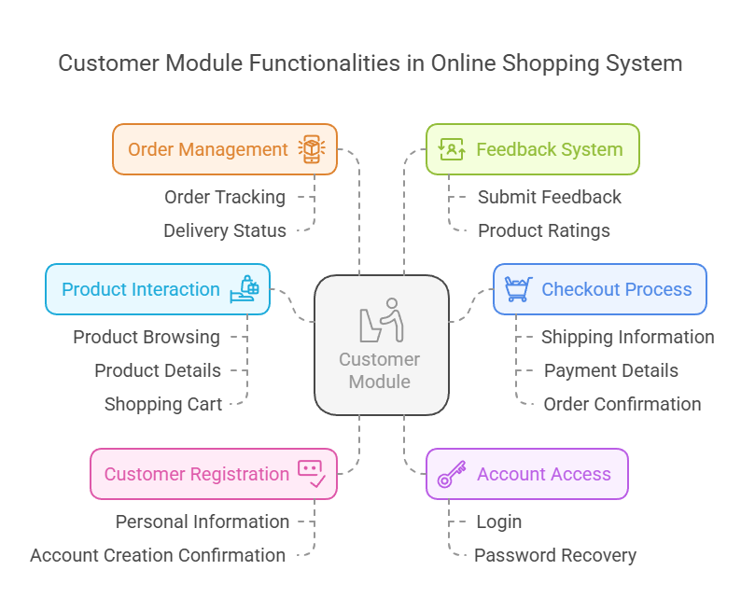

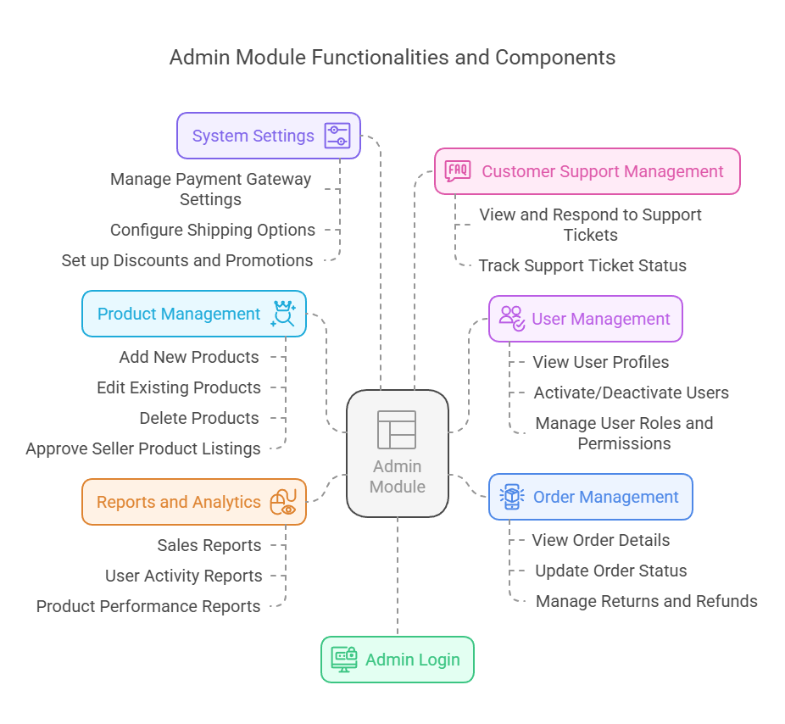

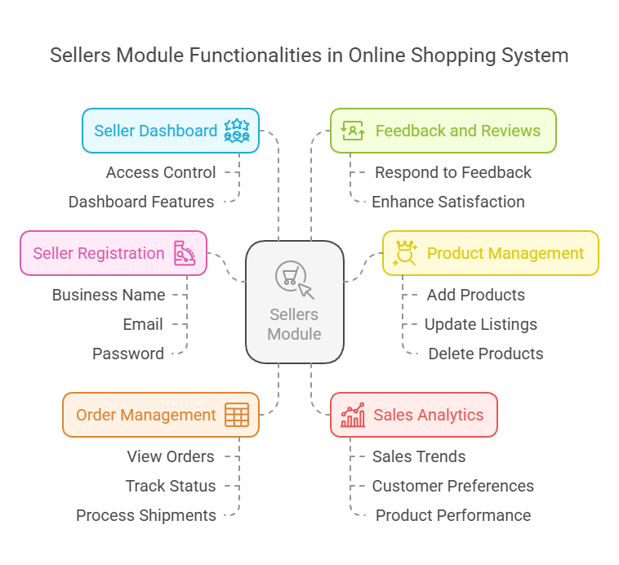
Use Case Diagram

Software Requirements Specification (SRS) for Online Shopping System

1. Introduction
1.1 Purpose
The purpose of this Software Requirements Specification (SRS) document is to outline the requirements for the Online Shopping System, a web-based platform that enables customers to browse, purchase, and review products, while allowing sellers to manage their inventory and sales. This document serves as a guideline for developers, stakeholders, and project managers to understand the system's functionality and constraints.
1.2 Scope
The Online Shopping System aims to provide a comprehensive e-commerce platform that connects customers and sellers. Key functionalities include user registration and login, product browsing, shopping cart management, secure checkout, order tracking, seller management, and customer support.
1.3 Definitions, Acronyms, and Abbreviations
- SRS: Software Requirements Specification
- UI: User Interface
- API: Application Programming Interface
- DB: Database
- Admin: System Administrator
- Seller: Merchant or Store Owner
- Customer: End-user who purchases products
1.4 References
- IEEE Std 830-1998 - IEEE Recommended Practice for Software Requirements Specifications
- Online Shopping System Project Documentation

2. Overall Description
2.1 Product Perspective
The Online Shopping System will be a standalone web application that interfaces with third-party payment gateways and delivery services. It will support multiple user roles, including customers, sellers, and administrators.
2.2 Product Functions
The system will provide the following functionalities:
- User registration and authentication
- Product management (for sellers)
- Product browsing and searching (for customers)
- Shopping cart and checkout process
- Order management and tracking
- Customer feedback and review system
- Reporting and analytics for sellers and admins
2.3 User Classes and Characteristics
- Customers: End-users who browse and purchase products.
- Sellers: Merchants who list and manage their products.
- Administrators: Users who manage the overall system, including user accounts, product listings, and reports.
2.4 Operating Environment
The Online Shopping System will be accessible via modern web browsers (Chrome, Firefox, Safari, Edge) on desktop and mobile devices. The system will be hosted on cloud infrastructure to ensure scalability and availability.
2.5 Design and Implementation Constraints
- Compliance with data protection regulations (e.g., GDPR, CCPA).
- Integration with third-party payment gateways (e.g., PayPal, Stripe).
- Support for various payment methods (credit/debit cards, digital wallets).

3. Specific Requirements
3.1 Functional Requirements
ID | Requirement
FR1 | The system shall allow users to register and create an account.
FR2 | The system shall provide a login mechanism for customers and sellers.
FR3 | The system shall allow sellers to add, edit, and delete product listings.
FR4 | The system shall enable customers to search for products using various filters.
FR5 | The system shall allow customers to add products to a shopping cart.
FR6 | The system shall provide a secure checkout process with payment options.
FR7 | The system shall allow customers to track their orders.
FR8 | The system shall enable customers to leave feedback and reviews for products.
FR9 | The system shall provide analytics and reporting features for sellers and admins.
FR10 | The system shall support customer inquiries and complaints through a support ticket system.
3.2 Non-Functional Requirements
ID | Requirement
NFR1 | The system shall ensure data security through encryption protocols.
NFR2 | The system shall be capable of handling 10,000 concurrent users.
NFR3 | The system shall have a response time of less than 2 seconds for all user interactions.
NFR4 | The system shall be compatible with all modern web browsers.
NFR5 | The system shall provide a mobile-responsive design for accessibility on various devices.
NFR6 | The system shall maintain a 99.9% uptime to ensure availability.
3.3 External Interface Requirements
3.3.1 User Interfaces
- The system shall have an intuitive and user-friendly UI for customers, sellers, and administrators.
3.3.2 Hardware Interfaces
- The system will operate on standard server hardware configured for web hosting.
3.3.3 Software Interfaces
- The system shall integrate with third-party APIs for payment processing and shipping services.
3.3.4 Communication Interfaces
- The system shall support email notifications for order confirmations, shipping updates, and feedback responses.

4. Acceptance Criteria
The system will be considered acceptable if it meets the functional and non-functional requirements outlined in this SRS document and passes all user acceptance testing conducted by stakeholders.

5. Conclusion
This Software Requirements Specification provides a detailed outline of the requirements for the Online Shopping System, ensuring all stakeholders have a clear understanding of the project scope, functionality, and constraints. The successful implementation of these requirements will result in a robust and efficient e-commerce platform that meets the needs of customers and sellers alike.

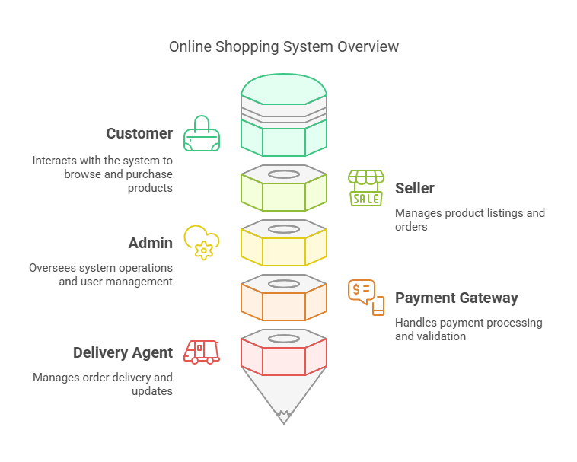

Activity diagram

Use Case Descriptions for Online Shopping System

1. Use Case: Customer Registration
Actors: Customer
Description: This use case allows new customers to create an account on the online shopping platform.
- Preconditions:
  - The user must have a valid email address.
- Postconditions:
  - The customer’s account is created, and they receive a confirmation email.
- Main Flow:
  - The customer navigates to the registration page.
  - The system displays a registration form.
  - The customer enters their personal information (name, email, password).
  - The customer submits the registration form.
  - The system validates the information.
  - The system creates the customer account and sends a confirmation email.

2. Use Case: Customer Login
Actors: Customer
Description: This use case allows registered customers to log into their accounts.
- Preconditions:
  - The customer must have a registered account.
- Postconditions:
  - The customer gains access to their account dashboard.
- Main Flow:
  - The customer navigates to the login page.
  - The customer enters their email and password.
  - The customer submits the login form.
  - The system validates the credentials.
  - The system redirects the customer to their account dashboard.

3. Use Case: Product Browsing
Actors: Customer
Description: This use case allows customers to search for and browse available products.
- Preconditions:
  - The customer must be logged into their account (optional for guest users).
- Postconditions:
  - The customer views a list of products based on their search criteria.
- Main Flow:
  - The customer navigates to the product listing page.
  - The system displays available products.
  - The customer can apply filters (category, price range, etc.).
  - The customer can search for products using keywords.
  - The system updates the displayed products based on the filters and search criteria.

4. Use Case: Checkout Process
Actors: Customer
Description: This use case allows customers to finalize their purchases and submit orders.
- Preconditions:
  - The customer must have items in their shopping cart.
- Postconditions:
  - The customer’s order is confirmed, and a receipt is generated.
- Main Flow:
  - The customer navigates to the shopping cart.
  - The customer reviews their selected items.
  - The customer clicks on the “Checkout” button.
  - The system prompts the customer to enter shipping information.
  - The customer enters payment details.
  - The customer submits the order.
  - The system processes the payment and confirms the order.

5. Use Case: Order Tracking
Actors: Customer
Description: This use case allows customers to track the status of their orders.
- Preconditions:
  - The customer must have placed at least one order.
- Postconditions:
  - The customer views the current status of their order.
- Main Flow:
  - The customer navigates to the order tracking page.
  - The customer enters their order ID.
  - The system retrieves the order details.
  - The system displays the current status of the order (e.g., processing, shipped, delivered).

6. Use Case: Manage Products (for Sellers)
Actors: Seller
Description: This use case allows sellers to manage their product listings.
- Preconditions:
  - The seller must be logged into their account.
- Postconditions:
  - The product listings are updated in the system.
- Main Flow:
  - The seller navigates to the product management page.
  - The seller selects to add a new product.
  - The seller enters product details (name, description, price, images).
  - The seller submits the product information.
  - The system adds the product to the seller's inventory.
  - The seller can also edit or delete existing products.

7. Use Case: Admin User Management
Actors: Admin
Description: This use case allows admins to manage user accounts.
- Preconditions:
  - The admin must be logged into their account.
- Postconditions:
  - User accounts are created, updated, or deleted as needed.
- Main Flow:
  - The admin navigates to the user management page.
  - The admin views a list of registered users.
  - The admin can add a new user or select an existing user to edit or delete.
  - The admin submits changes.
  - The system updates the user information accordingly.

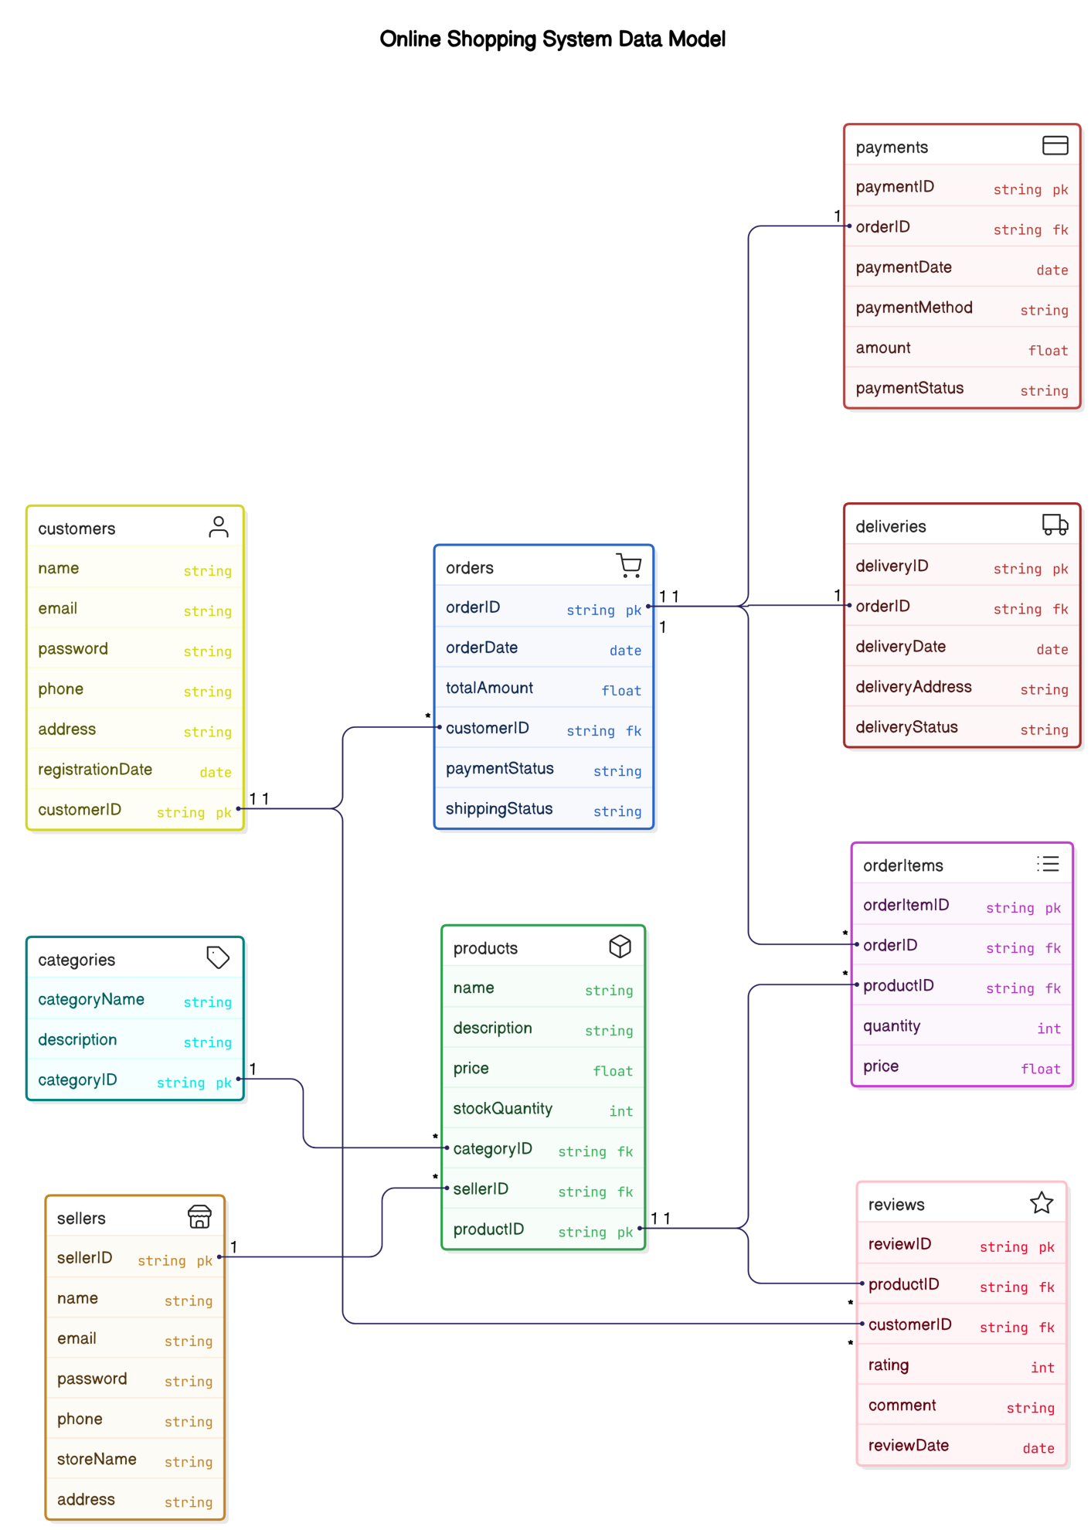

ER Diagram
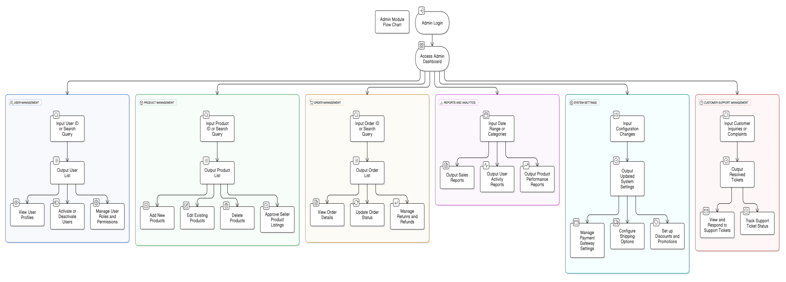
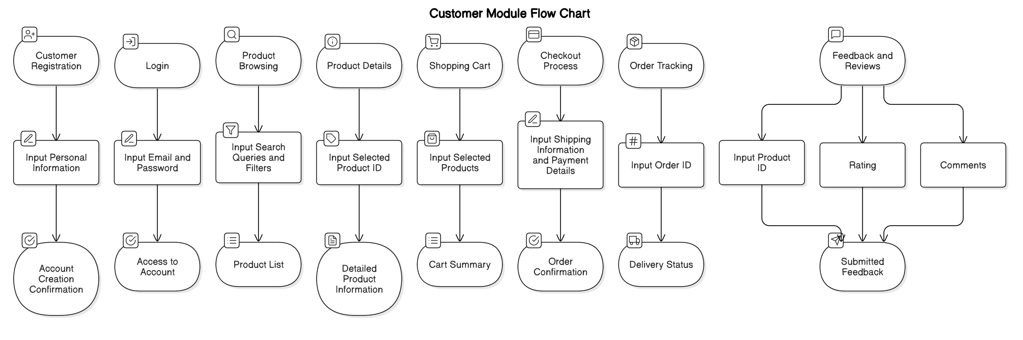

Data Flow Diagram

